# ENGF0001

# CSEEE – Challenge 2

# Team Proposal and Implementation Plan

**Team number:** CSEEE06

**Authors:** Wen Zequan, Filippo Fiocchi, Emily Yu, Femi-Sunmaila Ponmile, Michael Tang, Leo Xu

**Submission date: 1pm, Friday 13th November 2020**

University College London

2020/2021

**Table of Contents**

Introducton 3

Context and summary of research on the problem 3

Design process and criteria 4

Design proposal 5

Implementation plan 7

List of references 10

Appendices 11

**Introduction**

Our aim in this project is to construct a vaccine production plant in Uganda, which will produce vaccines to treat Tuberculosis from yeast. For yeast to grow well and produce the correct vaccine it will be grown in a bioreactor which enables the yeast to be heated and kept in a system of a specific pH, however the yeast must be kept in a stable environment, where the temperature is just right and the pH of the area is kept at the right level. The ideal temperature and pH may vary and will need to be altered depending on circumstances, like changes in the external environment. That is where our part of the project comes in.

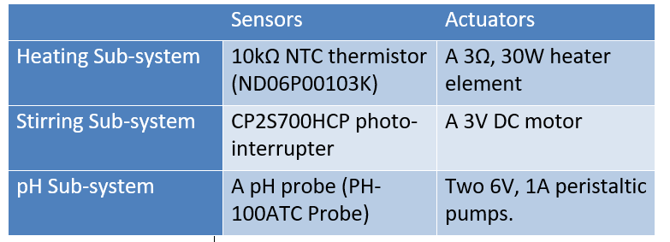Our team will be working on producing a control system which will oversee controlling the systems temperature and the pH of the solution the yeast is being contained in. The solution will also need to be mixed to ensure that the heat, and any chemicals added to the solution is evenly distributed. The bioreactor system will contain actuators to alter these characteristics and sensors to measure them:

Table 1

An algorithm will use the inputs from the sensors to alter how much voltage will be supplied to the corresponding actuator to ensure the internal attributes of the system are as close to the setpoints set by the user as possible. The algorithm will be held on an Arduino Uno, which will be connected to all components, so that they have access to the inputs of the sensors and can alter the outputs of the actuators. Finally, the data collected from the Arduino will be logged so that we will be able to ensure that the resulting changes of the system due to our algorithm are appropriate.

**Context and summary of research on the problem**

An estimated 145,000 children under five years of age die each year in Uganda and the country’s under-five mortality is estimated to be 45.8 per 1,000 live births in 2019 according to UNICEF. Childhood mortality in Uganda has dropped steadily between 1990 and 2019. Improvements occurred as a consequence of recognition and execution of effective child survival interventions. In particular, vaccination against Tuberculosis played a key role in the state’s fight against early mortality. In 2014 in Uganda, according to the BMC Public Health’s research [1], under-five children were 41% less likely to die if they received the BCG vaccine (against Tuberculosis). According to the same research the percentage of BCG vaccinated children was 79% in 2014. In Uganda, children usually receive the vaccine in the early phases of their lives. However, recent studies have revealed that the strong decrease in childhood mortality is not simply a direct consequence of Tuberculosis immunity [2-6]. This is caused by a strong correlation between BCG vaccination and an improvement in the overall health of children, due to lower probabilities for vaccinated children of contracting septicaemia [7], a respiratory infection. Moreover, as many studies have now proven the lethal combination of Tuberculosis and HIV, a country with 1.4 million registered people living with HIV, according to UNAIDS, will greatly benefit from Tuberculosis herd immunity. Uganda’s context states the importance of BCG vaccine production for the country's people's wellbeing.

By constructing a control system for the bioreactor, we will be able to provide a stable environment for the yeast to grow in, so that Uganda is able to produce the vaccine for TB. There are several reasons we decided to construct our bioreactor system in Uganda.

Firstly, a large proportion of Uganda’s population has contracted TB, and a proportion of those infected have a variant of the infection: multidrug and rifampicin resistant (or MD/RR) Tuberculosis. This is a mutated variation of the infection which is resistant to previously used vaccinations. So, the construction of a bioreactor in Uganda, will allow quick supply to a country who is in high demand of a vaccination to TB.

Whilst we could construct a vaccination development site anywhere, like in the UK, Uganda is likely to benefit much more than any other country due to their need for vaccination. This will reduce the need to export vaccines to Uganda, which will reduce the environmental impact of the delivery of vaccinations, since they will not need to be transported by plane, as well as will help Uganda become less dependent from developed countries regarding medications. Furthermore, this will reduce the overall price of vaccinations for the public health system as the production would be local.

Finally, Uganda is considered as one of the least developed countries in the world, this means that the combination of factors such as life expectancy or GDP per capita are lower than the majority of countries. In constructing a vaccine development site in Uganda, we will help improve the development of Uganda in the following ways:

Production of the vaccine in Uganda will mean that more of the population will have access to the vaccine, less people will die of Tuberculosis and the life expectancy will rise.

The vaccination development site will need people to monitor and maintain it to ensure that it is working as intended. This will create some employment opportunities for those living in Uganda, as well as educating more people about better hygiene and the infection itself. In doing these things this will provide more people with jobs, which will in turn increase the GDP per capita of the country.

**Design process and criteria**

To implement the bioreactor, we first planned out how each component of the system would need to be developed. Each of the sub-systems have two components to them, the circuits, which dictates how all the components are to be connected together, and the software, which dictates how the sub-system will behave.

The hardware will require our team to design circuits for each sub-system and connect them all together to the Arduino board in the correct way. The circuits are to be designed primarily using Multisim, and where possible Tinkercad. Tinkercad is useful as it allowed us to simulate how the Arduino will work in certain circuits and even allows the uploading of sketches to the microcontroller.

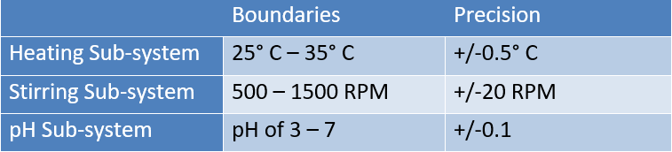Differently, the software will require code that monitors the correct functioning of the sub-systems, this means being able to remain within the boundaries and precisions shown in the table (see Table 2). The program will need a user interface to allow the user to have control and adjust the previously mentioned parameters to their liking. The UI will also be able to log data over time. To achieve this, we developed pseudocode (see Appendix A, B, C) and we will be implementing the Arduino code using Simavr.

Table 2

In the bioreactor, there are several design parameters that we must consider:

To maximize the performance metrics, we will run each system in their individual way to test if there are bugs and unexpected outcomes for multiple times before building the whole system. Apart from just testing the software bugs, we will also check if the bioreactor does register the correct values for temperature, stirring speed and, most importantly, pH by comparing the outputs of the sensors (converted to the correct units) with real measurements using Simavr.

If we want to control a high current load circuit, a transistor must be used to control the sub-system, this is because the Arduino uno is only supported for currents of up to 40mA, any higher would cause damage to the board.

A limitation is that values for the voltage output from the pH probe could be negative, which the Arduino will not be able to register as input. To solve this, we will have to make use of a potential divider circuit, converting the voltage to a positive value.

The sensor will output to the system a great amount of data, it would be a lot of effort if the microcontroller had to log and elaborate each value every millisecond. This represents a trade-off for our team, the less data we gather, the less precise our system will be. However, we believe logging data such as temperature every millisecond is useless, as it will not change drastically within such a short time period. That is why we decided, as it is shown in the pseudocode, to only measure, calculate and display figures every few seconds. This will avoid putting to much work on the limited capabilities of the Arduino UNO, as well as allowing the user to see data clearly.

Once the system is complete, we will need to ensure that the values reached are within the precisions previously mentioned. These uncertainties will act as our KPIs, if the system is precise enough that values lie within these uncertainties, then we know that the system is performing as expected.

**Design proposal**

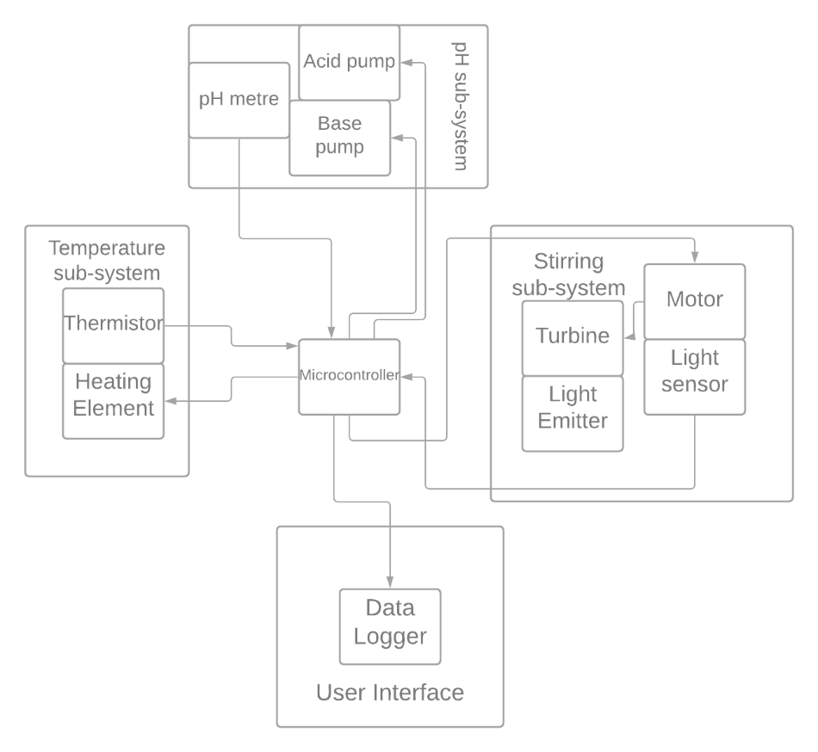When working on the design a general outline of the entire system was created. This allowed us to see from a high level the core components of our system, mainly being the thermal, pH and stirring sub-systems, the Arduino and the data logger. In this diagram we also show all the components in each sub-system, and the connections between them. For example, the Actuators are given input from the microcontroller, so they are connected:

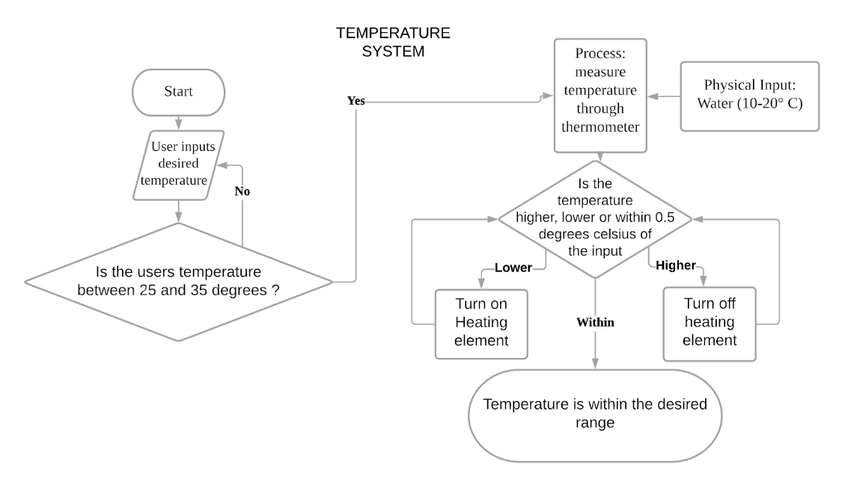Firstly, the heating sub-system is made up of thermistor and heating elements. Here, we are using the principle of temperature measurement with a thermistor which is its resistance changes with temperature. Thermistors have negative coefficient of resistance, so the resistance decreases with increasing temperature. Also, its temperature resistance characteristic is not linear and the graph of resistance against temperature is an exponential decay. Thus, the temperature range available for us to test might not be wide enough which means the centre temperature needs to be worked out. Then, when applying thermistors, the excitation current must be small to prevent self-heating - the temperature sub-system will contain a potential divider circuit to provide this small current.

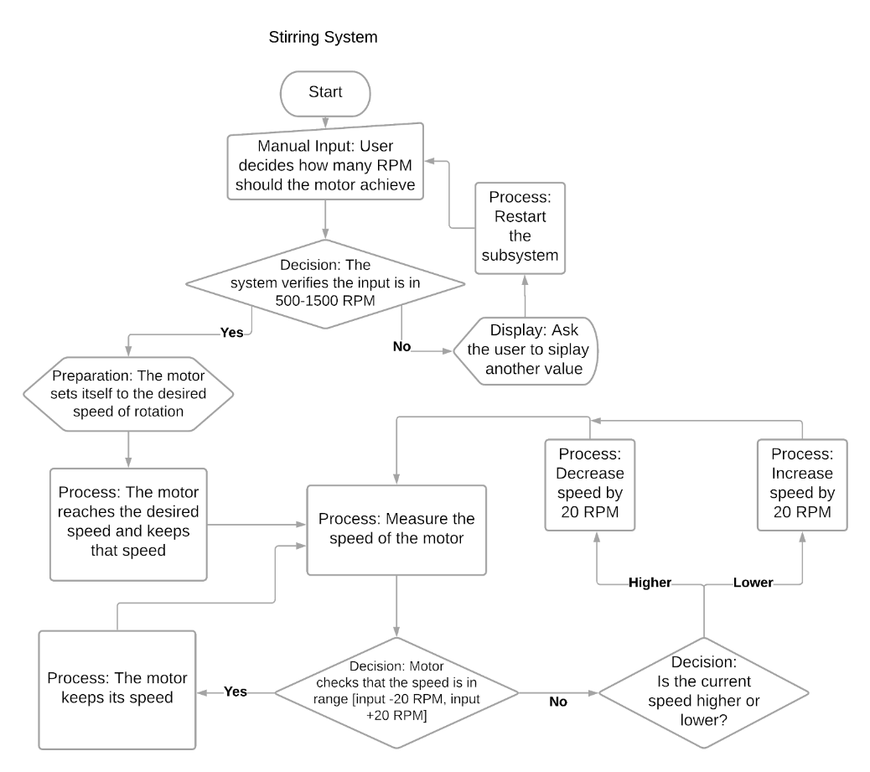Secondly a photodiode, potentiometer, motor and transistor are needed for making a stirring sub-system. For stirring sub-system working, the design needs to be under lights as a photodiode is a type of photodetector capable of converting light into electric current or voltage. Photodiodes highly depend on temperature and therefore, if the photon does not have sufficient energy, the photoelectric effect will not occur, meaning the circuit would not work. To deal with this, the stirring sub-system has to be driven under a suitable temperature. Also, for this circuit to be driven, the current has to be large enough, hence amplification is required.

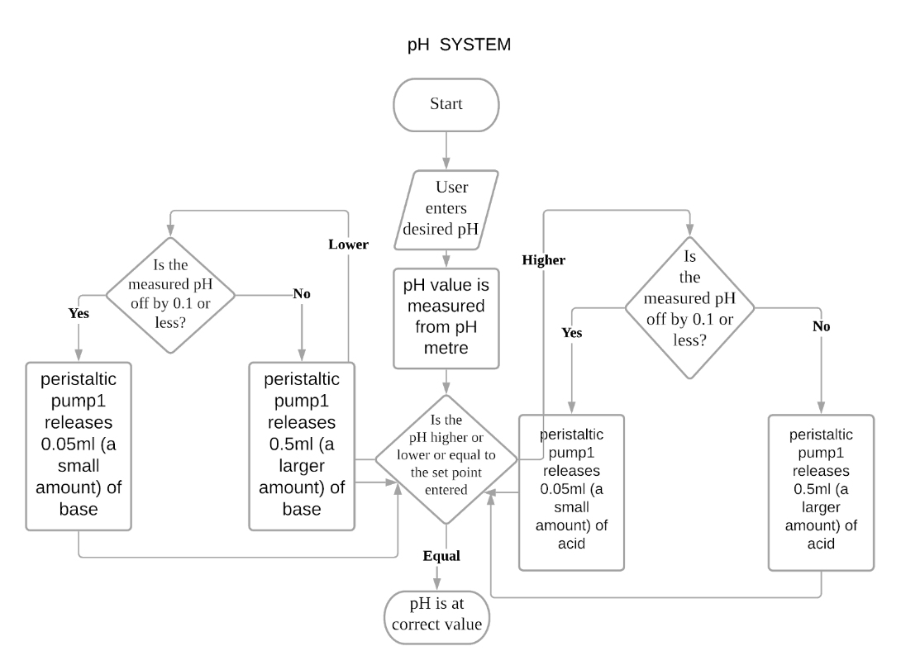Lastly, pH pumps and a pH meter are involved in the pH sub-system circuit. The pumps are high current loads, so we also need the transistor to control it. The pH meter has to be calibrated, and the pH calibration might be influenced by temperature and carbon dioxide absorption as chemical reactions and pH values are temperature dependent. Thus, when collecting the measurements from the pH probe, the temperature data from the thermistor need to be counted into the calculations.

**Implementation plan**

The implementation plan is a key part of the project. This allows us to monitor and adjust the progress while implementing our task. Our plan consists of splitting the system into five major tasks.

The heating sub-system leader, the stirring sub-system leader and the pH sub-system leader will be responsible for the first three tasks: implement the circuits for their own assigned sub-system. They will also need to figure out all the formulas and conversions between sub-system units into voltage for sensors and voltage into sub-system units for actuators. This should be done to support the Integration and User Interface leader and the Software leader to implement a correct and coherent code.

The following task will be carried out by the Integration and User Interface leader and the Software leader. They will work together to make sure the software correctly integrates all the sub-systems, deals correctly with storing and using data, and provides an adequate interface for the user.

The Sensors and Actuators leader will be working on calibrating and testing each sensor and actuator to make sure they can cooperate harmoniously to form our Bioreactor.

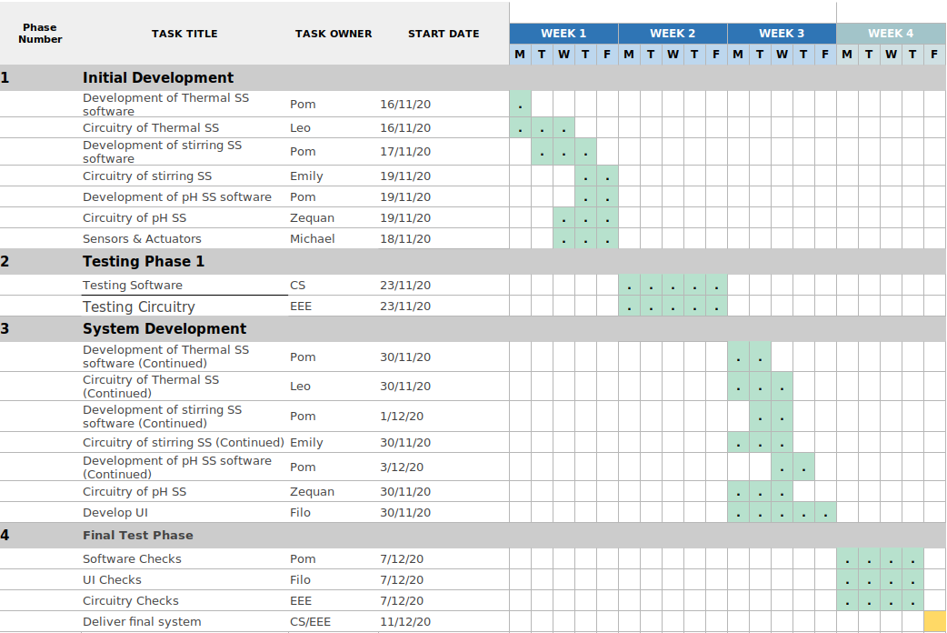

The team aims to start by designing the correct circuits for all the sub-systems. After this has happened, everyone will be able to start with their own task. The circuits will be the base to allow the completion of the project. Once circuits are done, the User Interface leader and the Software leader will start working on the actual Arduino code, using the logical structure of the block diagrams and of the pseudocode. They will be assisted by the subsystems leaders when dealing with conversions, formulas and the specifications for sensors and actuators. Simultaneously, the Sensors and Actuators leader will check the components and the code as they are being developed by carrying out calibration and testing.

We believe this strategy will allow our team to achieve the following goals:

* Allow the user to input a desired temperature between 25° C and 35° C, a desired rotation speed between 500 RPM and 1500 RPM and a desired pH between 3 and 7
* Maintain the temperature within +/- 0.5° C from the user’s input
* Maintain the rotation speed within +/- 20 RPM from the user’s input
* Maintain the pH very closed to the user’s input, most likely within +/- 0.1
* Record and log data

We believe our objectives are achievable if investing a lot of effort in calibration and testing. We will be able to capture data from the system through the sensors, however the results we get may differ from the actual real-world values we should get. This often occurs because of noise, external factors which alter the result of the outputs of sensors. That is why we believe our objectives are only achievable by trying to use calibration techniques to ensure that the values we record are as close to the real world expected values as possible.

The system will fetch the output from the sensors, e.g. the thermistor, photointerrupter etc, convert the input from an ADC value to the desired unit, being either pH, temperature, or RPM. This is already a form of calibration as we need to alter data received from the inputs, as displaying the ADC value does not provide the user with useful information about the system. For example, the Arduino will receive an ADC from the thermistor representing the voltage. This ADC value will need to be converted into the actual voltage, in mV. Further calculations using information from the data sheet can then be carried out to map this voltage to the temperature. However, the system can possibly still have some inconsistencies which will alter the thermistor output. To mitigate the effect of these inconsistencies, rather than receiving and displaying the thermistor output immediately, we could take in a few values from the thermistor, perhaps 5, calculate their average, and then display that instead. While this slightly reduces the amount of data being displayed per unit time, the data will be more accurate, as any anomalous data points will have a smaller effect. Another strategy would be to take the median of n data points, this way any extreme values will not be included.

We will try to use calibration techniques to ensure that the values we record are as close to the real world expected values as possible. To see if our calibration techniques are successful, we will need to test our results against the real-world values and create a way of visualising the difference between our results and the expected ones. This is where testing comes in. Unlike calibration from the ADC value to the voltage input to the Arduino, testing will work the same for every single sub-system. Testing is a way of confirming that our calibration method was good enough. Simvar outputs values for what the temperature of the system would be if measured by a thermometer, and what the RPM would be if measured by a tachometer. Using these values, we can plot graphs and create tables which can be used to compare our calibrated values with the “real world” values. Testing will also be needed when comparing the temperature set by the user with the temperature of the system. Our specification of the system states that the control system should be able to get the temperature of the system within +/- 0.5 degrees within the setpoint and the RPM between +/- 20 RPM between the setpoint. Graphs of the measurement against time when set to a specific value through the UI can be plotted to visually prove whether the control system meets the specification.

**List of References**

1. Nankabirwa, V., Tumwine, J.K., Mugaba, P.M. et al. Child survival and BCG vaccination: a community based prospective cohort study in Uganda. BMC Public Health 15, 175 (2015). https://doi.org/10.1186/s12889-015-1497-8 https://bmcpublichealth.biomedcentral.com/articles/10.1186/s12889-015-1497-8
2. Roth A, Garly ML, Jensen H, Nielsen J, Aaby P. Bacillus Calmette-Guerin vaccination and infant mortality. Expet Rev Vaccine. 2006;5(2):277–93.
3. Shann F. Commentary: BCG vaccination halves neonatal mortality. Pediatr Infect Dis J. 2012;31(3):308–9.
4. Aaby P, Roth A, Ravn H, Napirna BM, Rodrigues A, Lisse IM, et al. Randomized trial of BCG vaccination at birth to low-birth-weight children: beneficial nonspecific effects in the neonatal period? J Infect Dis. 2011;204(2):245–52.
5. Biering-Sorensen S, Aaby P, Napirna BM, Roth A, Ravn H, Rodrigues A, et al. Small randomized trial among low-birth-weight children receiving bacillus Calmette-Guerin vaccination at first health center contact. Pediatr Infect Dis J. 2012;31(3):306–8.
6. Roth AE, Stensballe LG, Garly ML, Aaby P. Beneficial non-targeted effects of BCG--ethical implications for the coming introduction of new TB vaccines. Tuberculosis (Edinb). 2006;86(6):397–403.
7. Jason J, Archibald LK, Nwanyanwu OC, Kazembe PN, Chatt JA, Norton E, et al. Clinical and immune impact of Mycobacterium bovis BCG vaccination scarring. immunityInfect Immun. 2002;70(11):6188–95.
8. United Nations: Committee for Development Policy, 2018: https://www.un.org/development/desa/dpad/wp-content/uploads/sites/45/publication/ldc_list.pdf
9. L.B. Bullerman, Encyclopedia of Food Sciences and Nutrition (Second Edition), 2003

**Appendices**

Appendix A (Temperature Sub-system pseudocode)

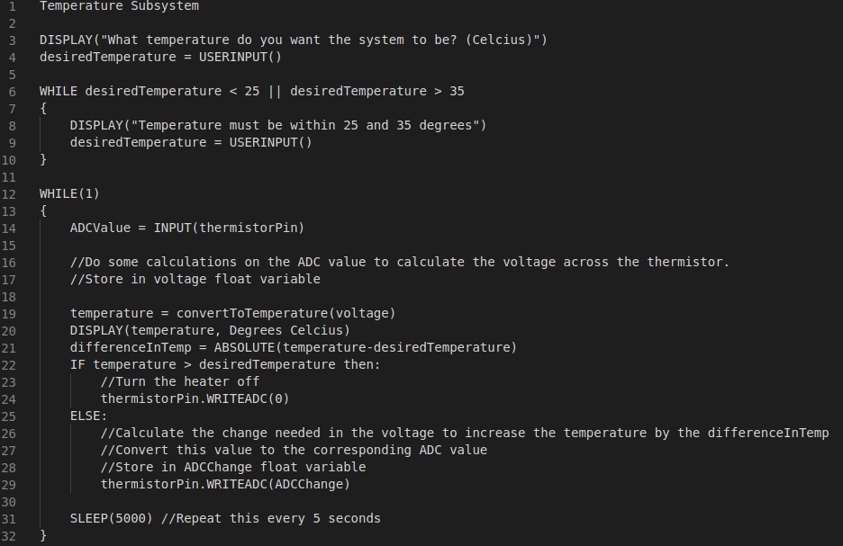

Appendix B (Stirring Sub-system pseudocode)

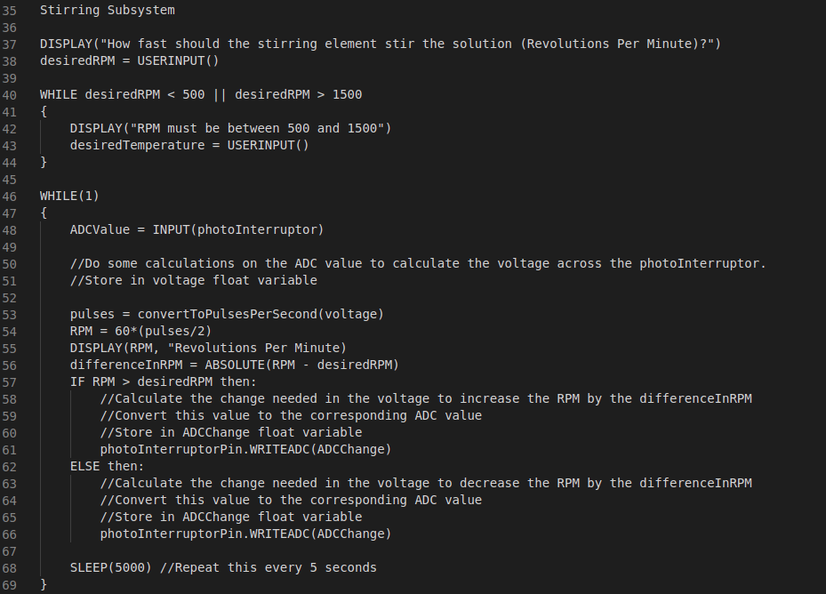

Appendix C (pH Sub-system pseudocode)

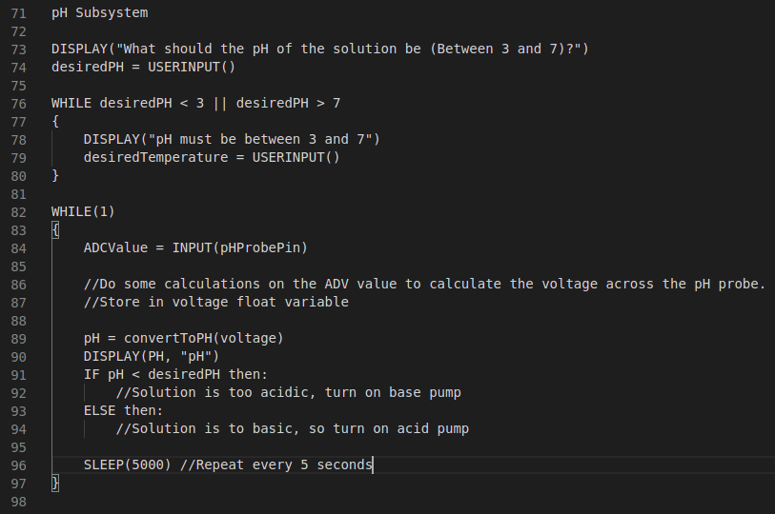

Appendix D (pH Sub-system circuit)

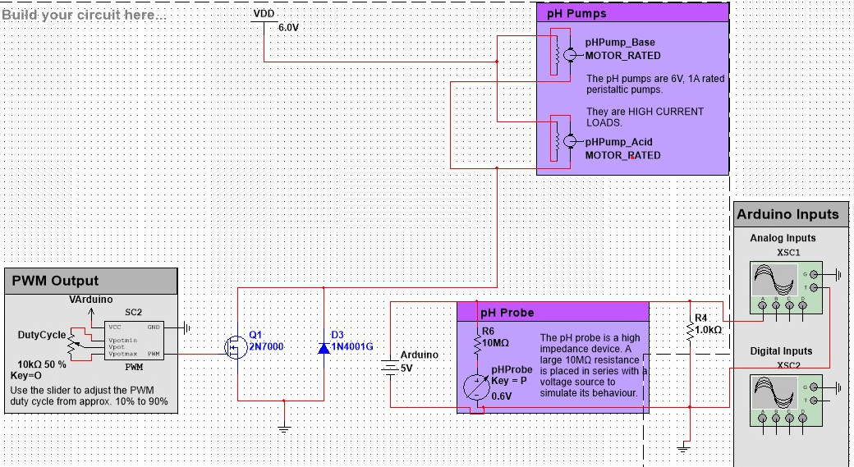

Appendix E (Stirring Sub-System circuit)

